VISVESVARAYA TECHNOLOGICAL UNIVERSITY

“Jnana Sangama”, Belgaum -590014, Karnataka.



PROJECT WORK-2 REPORT

ON

“FIKA – WATCH MOVIES AND SHOWS

ONLINE TOGETHER WITH FRIENDS”

Submitted by:

**HARSHIL DOSHI (1BM19CS057)**

**HEMANG SINGH(1BM19CS061)**

**NEHA B CHADAGA(1BM19CS098)**

**NIKITA PARAS TOLIYA(1BM19CS103)**

***Under the Guidance of***

Dr. Nandhini Vineeth Assistant Professor

***in partial fulfillment for the award of the degree of***

BACHELOR OF ENGINEERING

***in***

COMPUTER SCIENCE AND ENGINEERING



B.M.S. COLLEGE OF ENGINEERING (Autonomous Institution under VTU)

BENGALURU-560019 JUNE 2021

B. M. S. College of Engineering,

Bull Temple Road, Bangalore 560019

(Affiliated To Visvesvaraya Technological University, Belgaum)

Department of Computer Science and Engineering



C ERTIFICATE

**This is to certify that the project work entitled “FIKA – WATCH MOVIES AND SHOWS TOGETHER WITH FRIENDS” carried out by:**

HARSHIL DOSHI(1BM19CS057),

HEMANG SINGH(1BM19CS061),

NEHA B CHADAGA (1BM19CS098),

NIKITA PARAS TOLIYA(1BM19CS103) who are bonafide students of B. M. S. College of Engineering. It is in partial fulfillment for the award of Bachelor of Engineering in Computer Science and Engineering of the Visveswaraiah Technological University, Belgaum during the year 2021. The project report has been approved as it satisfies the academic requirements in respect of Project Work-2(19CS4PWPW2) work prescribed for the said degree.

|  |  |  |
| --- | --- | --- |
| Signature of the Guide  Dr. Nandhini Vineeth Assistant Professor |  | Signature of the HOD  Dr. Umadevi V.  Prof & Head of Dept of CSE |
| BMSCE, Bengaluru |  | BMSCE, Bengaluru |
|  | External Viva |  |
| Name of the Examiner |  | Signature with date |

B.M.S. COLLEGE OF ENGINEERING

DEPARTMENT OF COMPUTER SCIENCE AND ENGINEERING



DECLARATION

We, HARSHIL DOSHI(1BM19CS057), HEMANG SINGH(1BM19CS061),

NEHA B CHADAGA (1BM19CS098), NIKITA PARAS TOLIYA(1BM19CS103)

students of 4th Semester, B. E, Department of Computer Science and Engineering, BMS College of Engineering, Bangalore, hereby declare that, this Project Work-2 entitled **"FIKA"** has been carried out by us under the guidance of Dr.Nandhini Vineeth, Assistant Professor, Department of CSE, B.M.S. College of Engineering, Bangalore during the academic semester February-June 2021.

We also declare that to the best of our knowledge and belief, the development reported here is not from part of any other report by any other students.

Signature

HARSHIL DOSHI(1BM19CS057),

HEMANG SINGH(1BM19CS061),

NEHA B CHADAGA (1BM19CS098),

NIKITA PARAS TOLIYA(1BM19CS103)

# TABLE OF CONTENTS

|  |  |  |
| --- | --- | --- |
| **Serial No.** | **TITLE** | **PAGE NO.** |
| 1 | **Introduction** | 1-4 |
| 1.1 | Overview | 5 |
| 1.2 | Motivation | 5 |
| 2 | **Software Requirement Specification** | 6 |
| 2.1 | Hardware Requirements | 6 |
| 2.2 | Software Requirements | 6 |
| 3 | **ER diagram of the project** | 7 |
| 4 | **Schema of project** | 8 |
| 5 | **User Interface Design** | 9 |
| 5.1 | 1. HOME PAGE | 9 |
| 5.2 | 2. LOGIN AND SIGNUP PAGE | 12 |
| 5.3 | 3.STREAMING PAGE | 14 |
| 5.4 | 4.REVIEW FORM | 18 |
| 5.5 | 5.CONTACT US | 19 |
| 5.6 | 6.ABOUT US | 20 |
| 5.7 | 7.FEEDBACK FORM | 21 |
| 5.8 | **8.ADMIN PAGE** | 22 |
| 5.9 | REFERENCES |  |

**INTRODUCTION**

* 1. **Overview**

**Our website entitled “FIKA – Watch Together”, is a website made on the thought of relaxing during these tough times, which we are facing due to the pandemic, since a long time now.**

**FIKA is a platform, which facilitates various users to create an account, login and then join or create a room, and watch Movies/Shows from a large list of choices, with friends and family, with a fun and interactive chat window.**

**During these tough times, it provides a way for friends and family to connect with each other and spend some time together in a fun way, by watching the movies or shows of their choice.**

**We have made this website keeping in mind the situation currently, and we are really excited to share it amongst more and more people, so they can also watch their favorite movie or show with their friends and also give us some reviews and feedbacks on our work and effort.**

* 1. **Motivation**

**The main motivation behind choosing “FIKA” as our topic for this project, is the current prevailing situation. From working outside, going to schools, colleges and offices, all of us were put in a situation, which we never thought would arise, the situation of staying at home for hours and months and now it’s over a year.**

**When we used to go out for our respective duties, students to schools and colleges to study and adults to their jobs, we used to meet different people, interact with them and learn something new every day. The process of sharing of ideas would take place, but due to the pandemic, all of this has stopped. And staying at home for long hours has made us all feel stressed, raised the level of anxiety and caused many other problems too.**

**We, as a team thought let us create an environment or a platform, where people can spend their time together with their friends or family who are far away from them.**

**All of us used many online streaming platforms in the past few months, either to watch movies or play games or many other things as such. We thought let us do something different than these platforms. So then came the perfect idea for our website “FIKA – WATCH TOGETHER WITH FRIENDS AND FAMILY”.**

**Usually, we see movies sitting at home, but how would it be if we see them with our friends or family, who are away from us, if all could see it together and interact with each other. Isn’t it exciting, we felt it is. Do try using our website and letting us know your experience.**

# SOFTWARE REQUIREMENTS

* 1. **Hardware Requirements:**
     + A PC with the following or greater specifications:
       - Intel Core i3 or higher
       - 8 GB RAM
       - 500 GB Hard Drive
     + A stable internet connection (2Mbps or higher)
  2. **Software Requirements:**
* Operating system : Windows, Linux
* Front end technologies are : HTML, CSS, JavaScript
* IDE : VS Code
* Backend requirement : NODE JS
* Server : LOCAL server

(This is just a sample for reference only)

1. **ER DIAGRAM OF THE PROJECT**

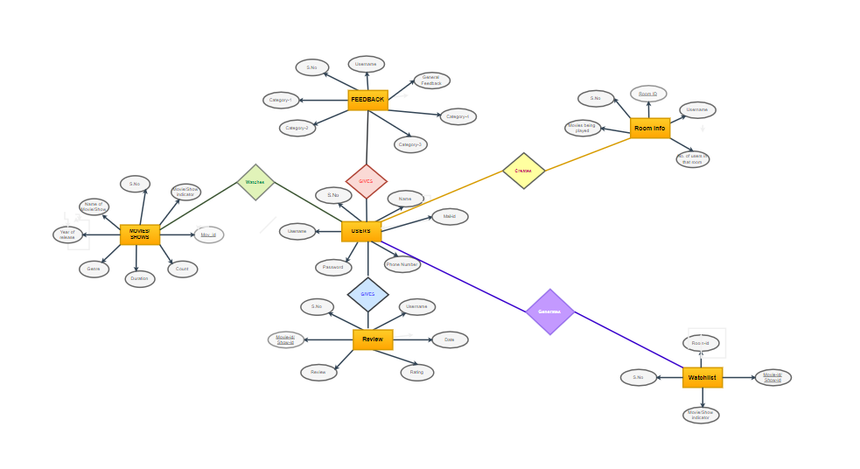

1. **SCHEMA OF THE PROJECT**

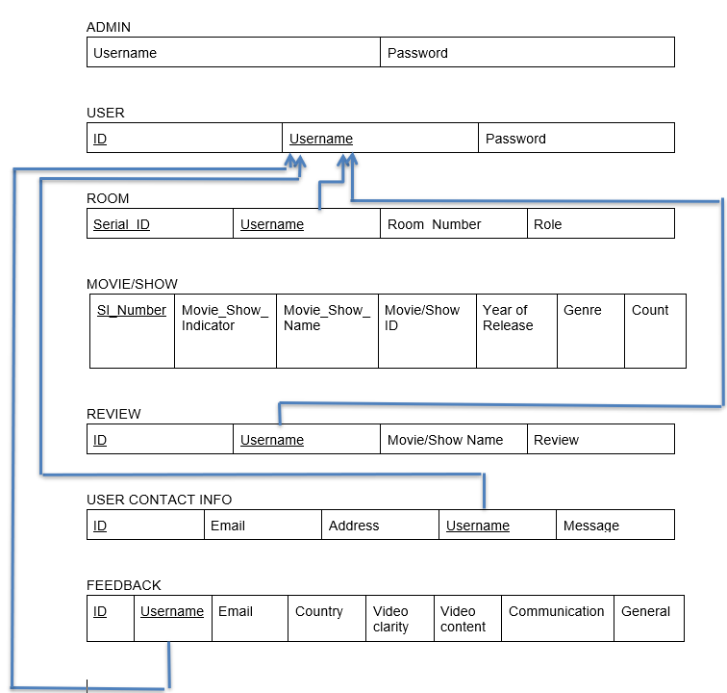

USER INTERFACE DESIGN

**1.HOME PAGE:**

This is the starting page of the website which gives a brief introduction about what our website offers. It shows a list of movies and tv shows available to watch in the created user rooms. It also displays few movie/show reviews given by our users.

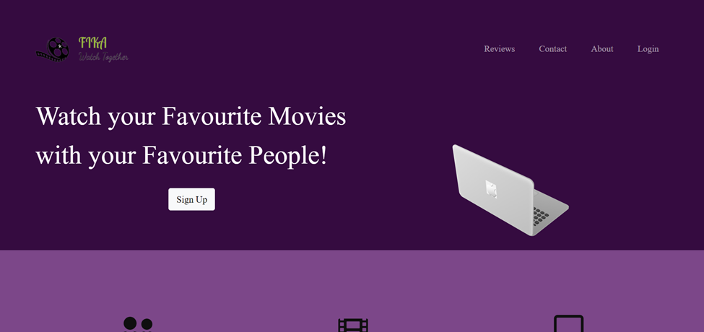

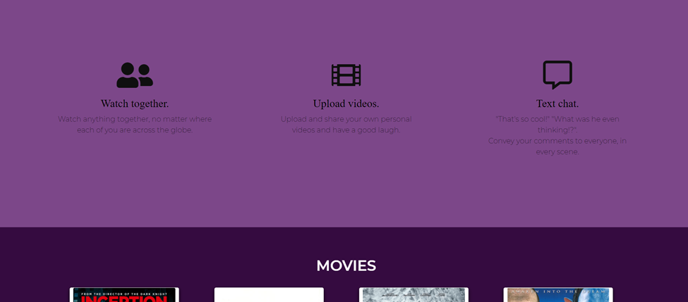

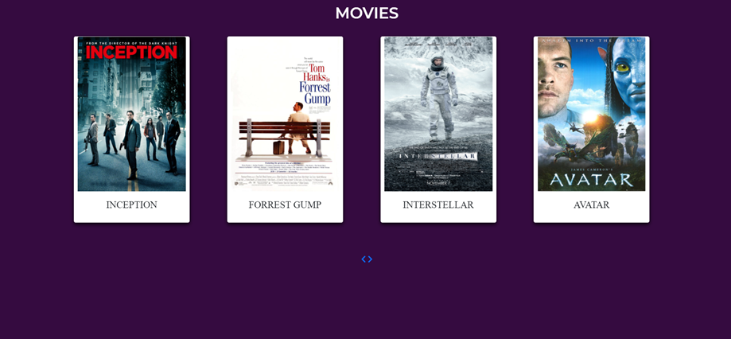

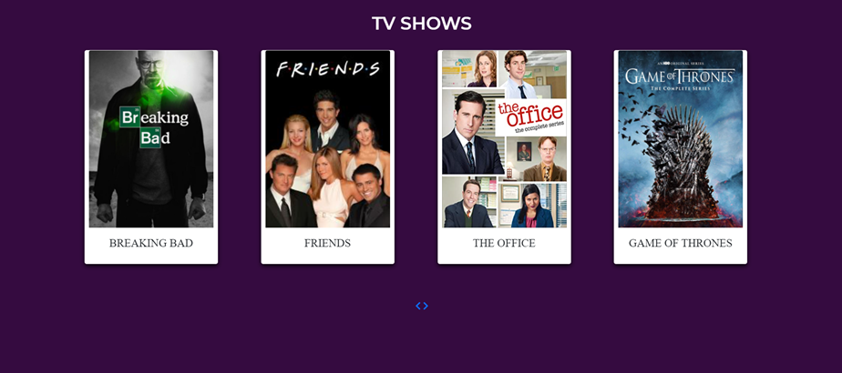

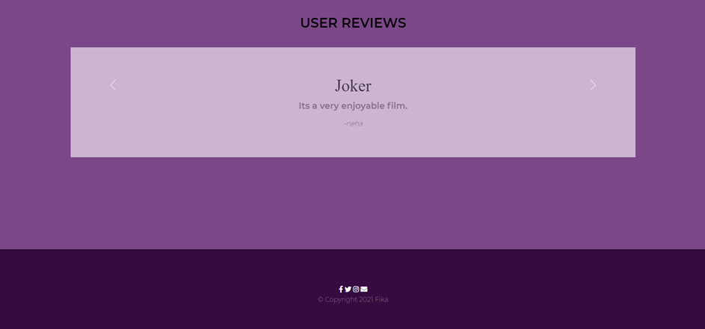

**2.LOGIN AND SIGNUP PAGE:**

The user lands on this page after clicking on the login or signup button from the home page. Here we have added a sliding login and signup form, where a new user has to signup first by entering username, email and password, and then with those details, the user can login and enjoy streaming with friends on our website. The contrasting feature of this page is the animated gradient changing background with a “FIKA” logo designed and created by us.

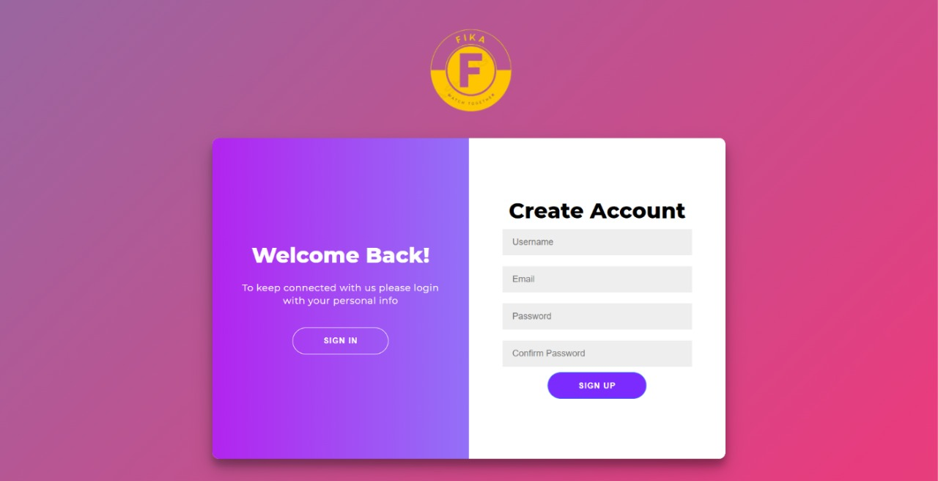

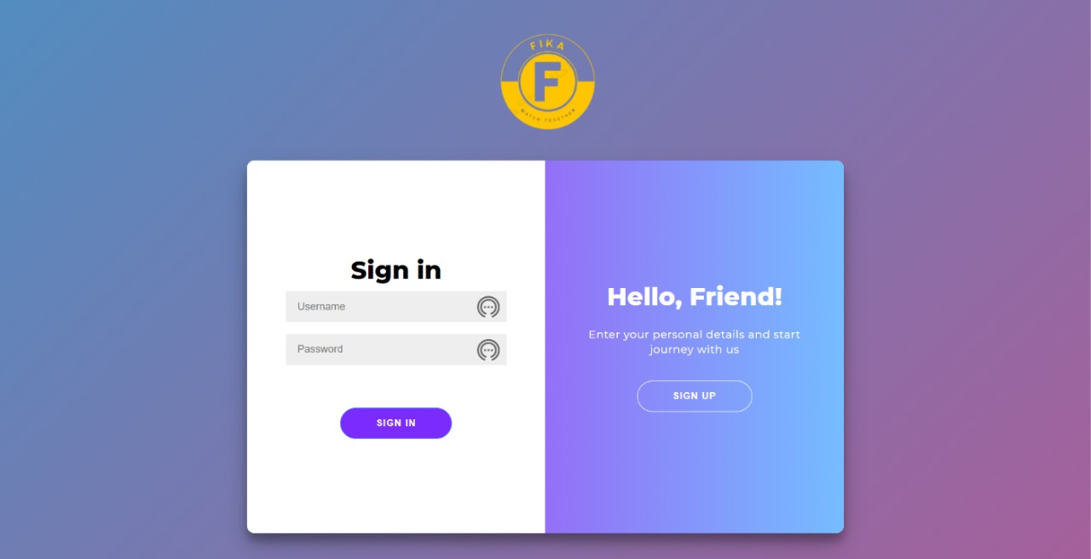

**3.STREAMING PAGE:**

This page allows users to watch movies and chat live with friends. The room owner is provided with a private room code and can share this code with his friends who can use it to join the room later on, at the top we have Room number as well as a clock has been provided that denotes the time for which the room has been active then we have a logout button under the user's name for ease, while watching movie user has also been provided with few options like to play, pause, download movie, volume adjustment and a picture in picture display as well as a full screen display.

Then as we move down, they have been provided with few more options like trending movies which shows the top five movies based on the rating by users and then a change room master option that lets the owner of room transfer the ownership to another user, then there we have a review form for users where they can provide a review of a movie of their choice.

Then below that we have two categories movies and shows both featuring some movies and shows of different genres, the room master can choose a movie or show of their choice and stream it in the room with his friends.

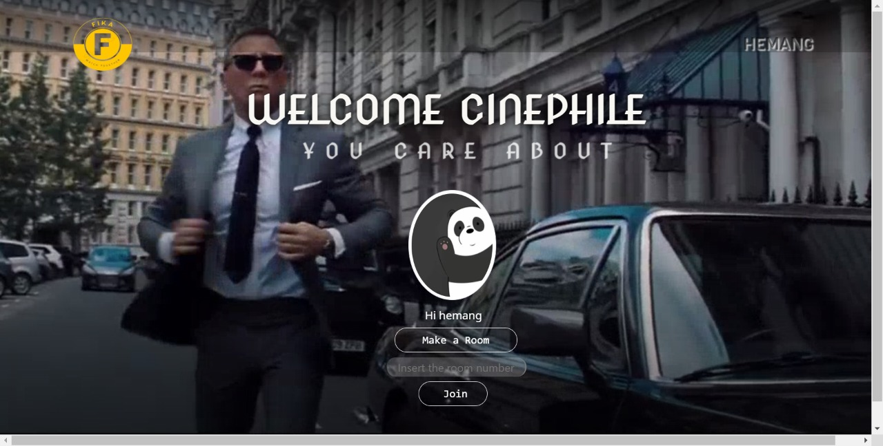

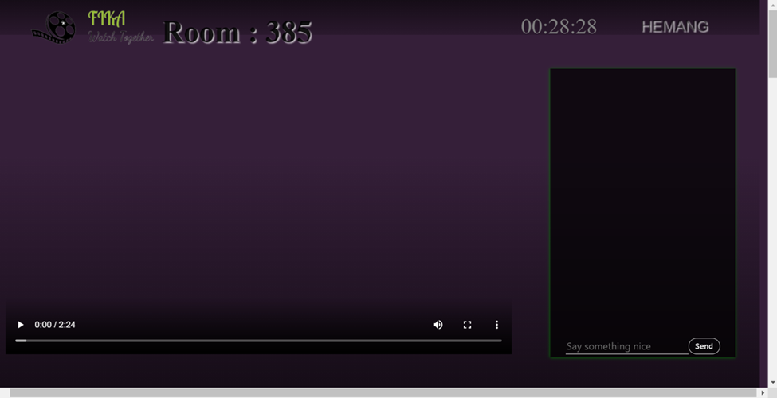

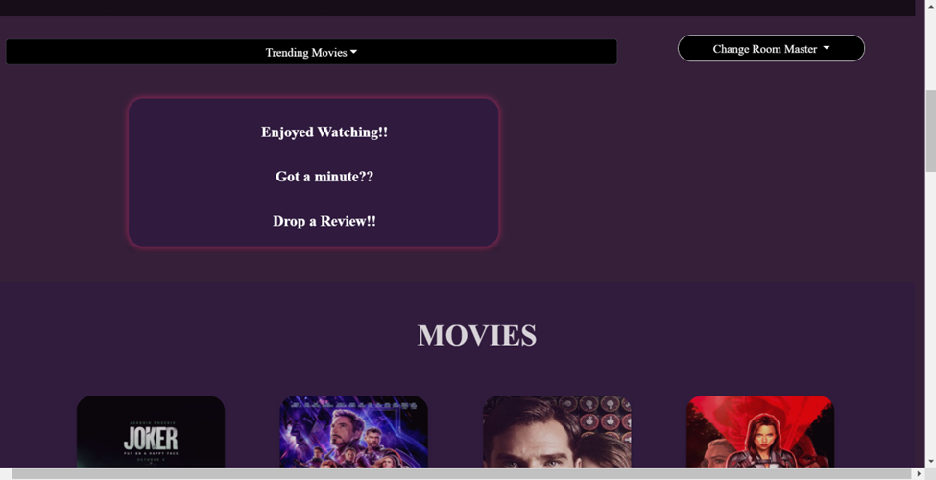

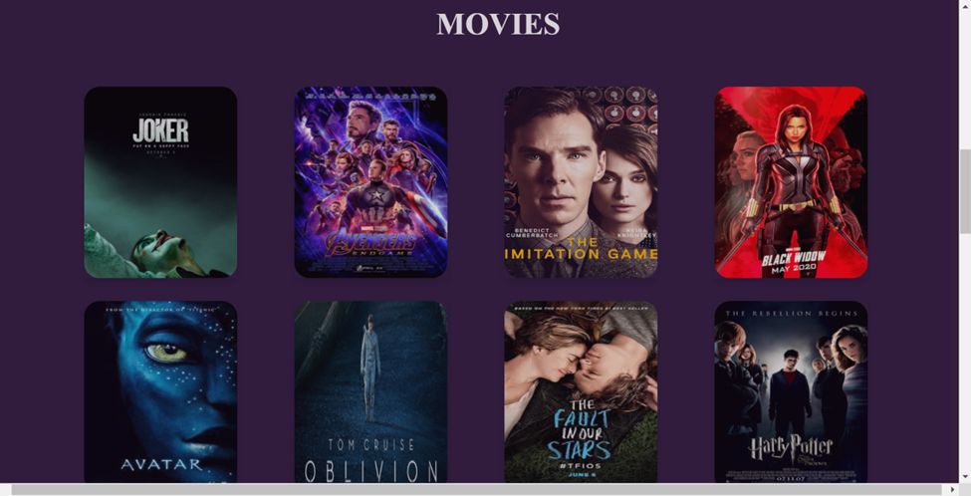

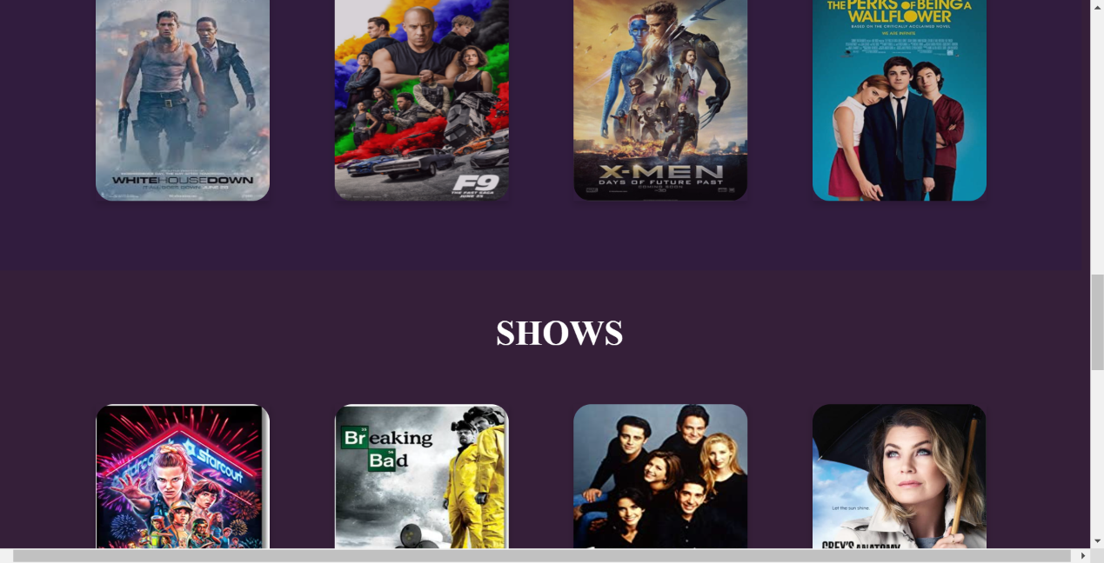

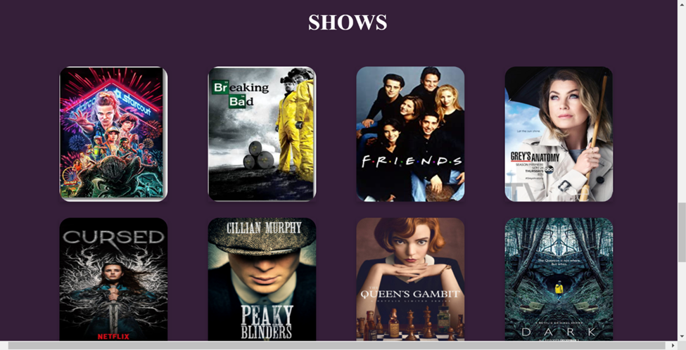

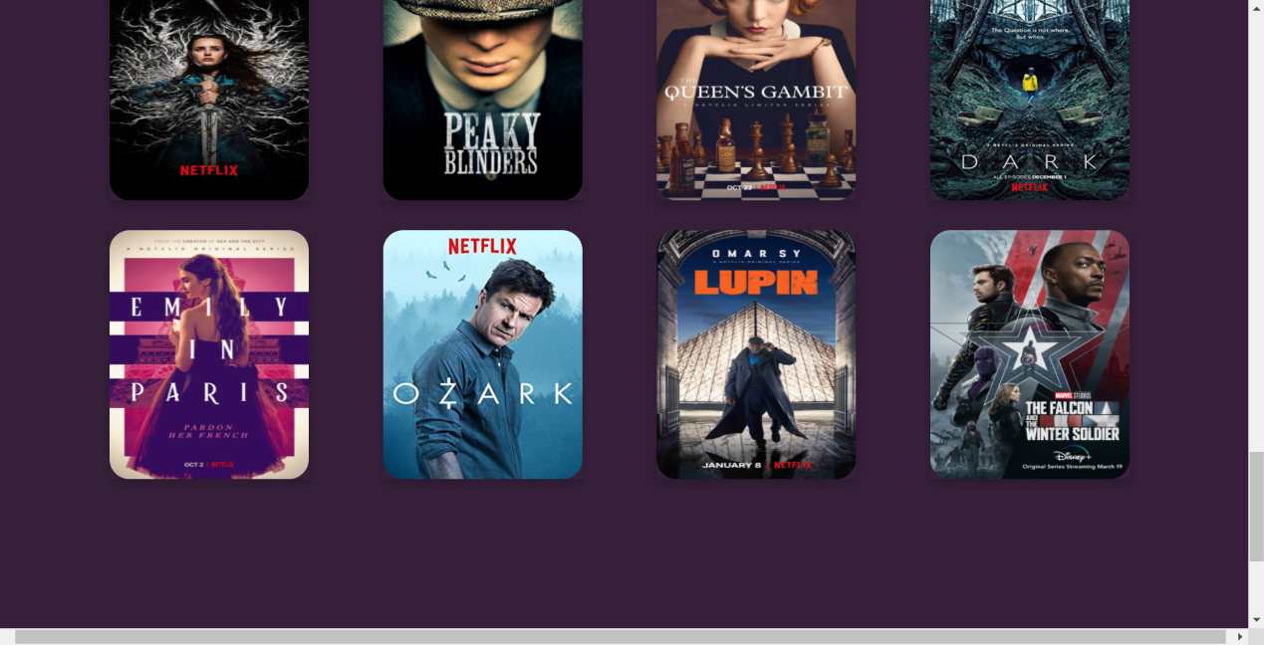

**4.REVIEW FORM:**

The streaming page includes a review form for the movie, it is present as a card on this page. It asks the user to give a review on the movie, and also rate the movie by selecting the number of stars he/she wants to give.

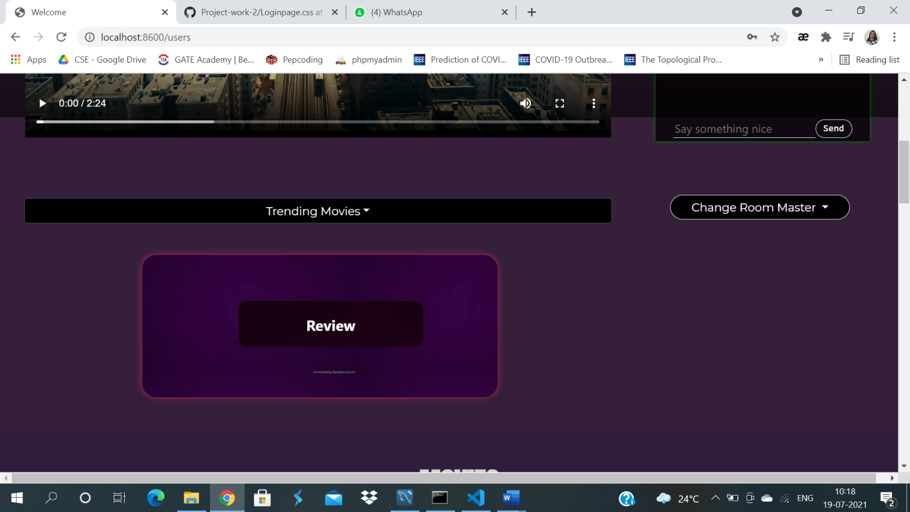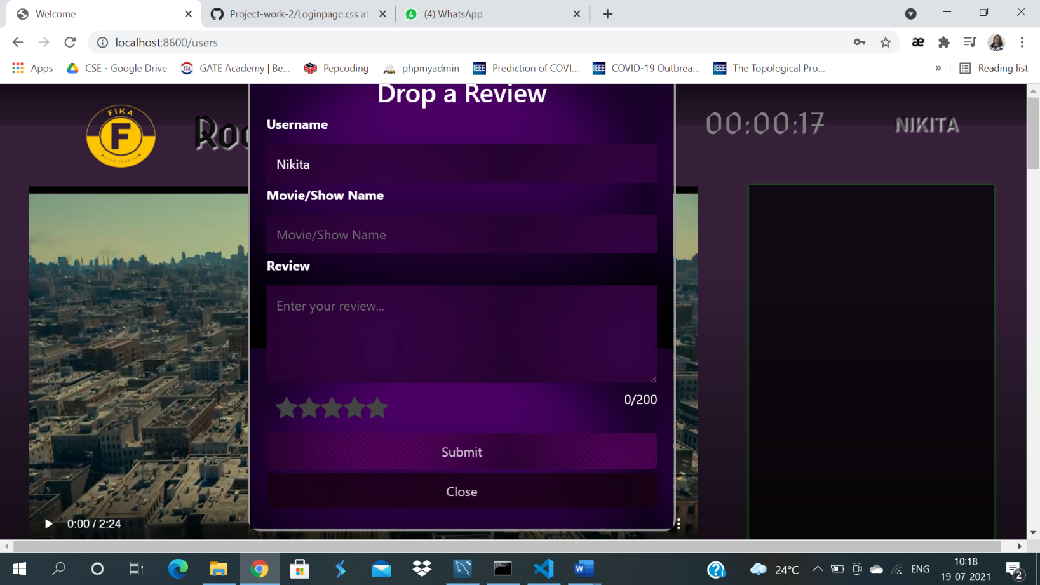

**5.CONTACT US:**

This page includes an animated background, as like the login and signup page, with our “FIKA” logo. It consists of a general contact us form to reach out to us, if the user has any message for us, they can just drop it here, and we will get back to them.

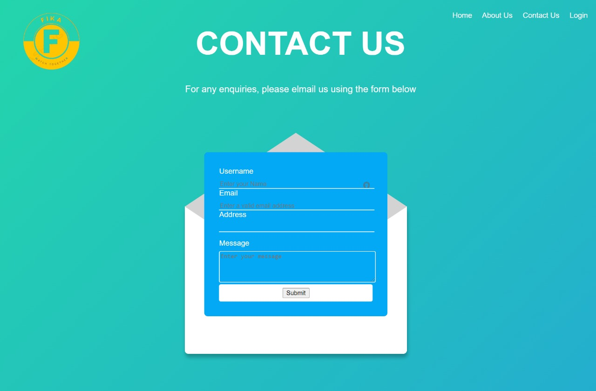

**6.ABOUT US:**

This is just an information page, which includes our team members and basic information about us. In addition to this, the page also includes a feedback form link in the form of a button, by clicking on which the user will be directed to a feedback page.

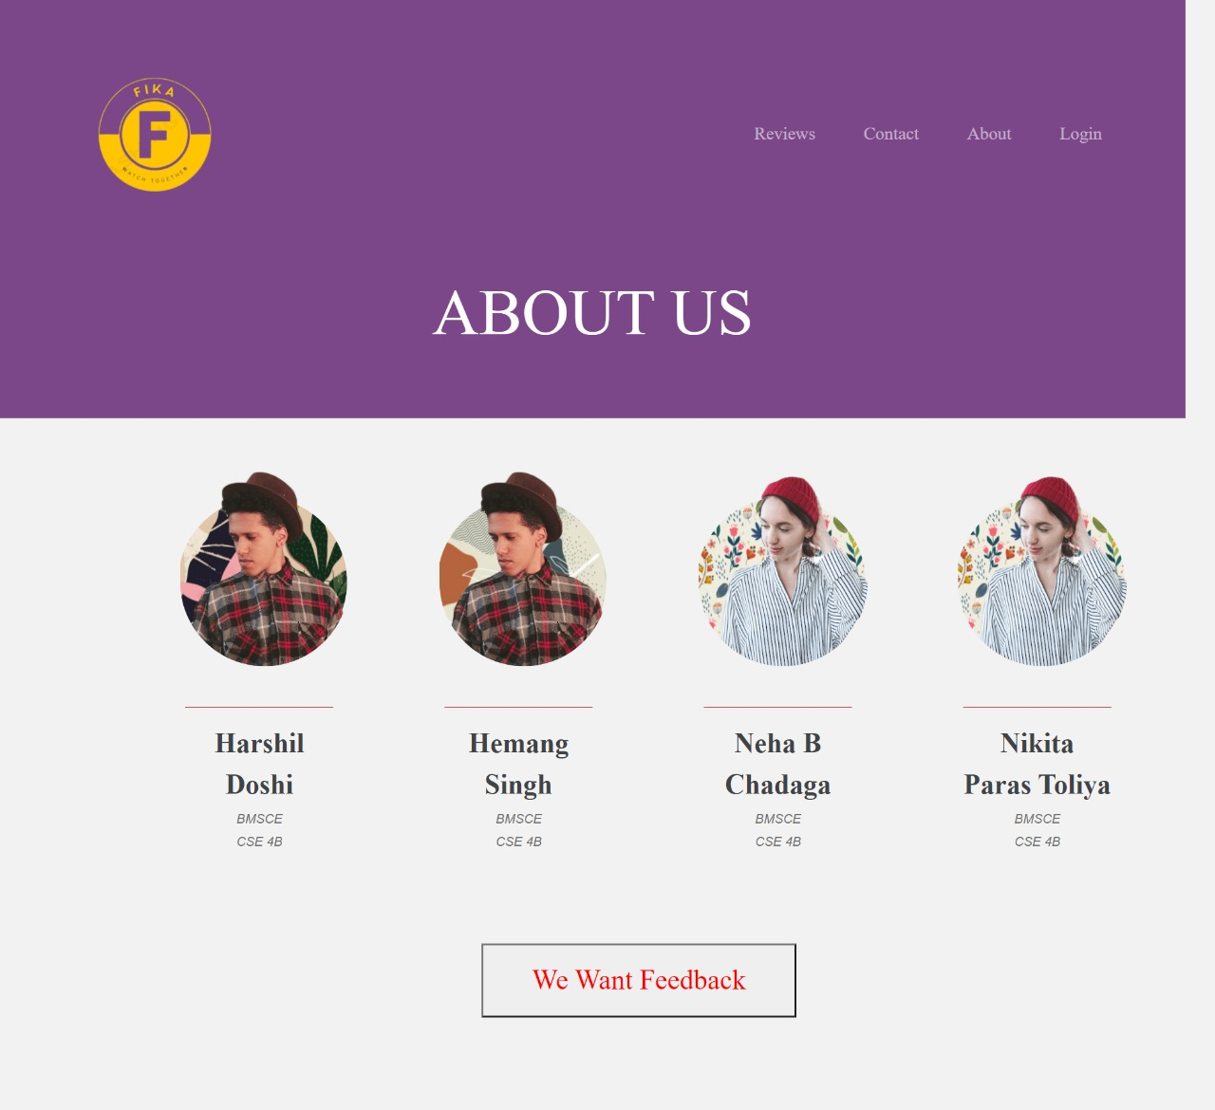

**7. FEEDBACK FORM:**

The user lands on this page by clicking the “I WANT FEEDBACK” button, a feedback form asking for the various qualities and aspects of the website opens up in front of the user, where we ask the user to first enter his basic personal details such as name, email and then we ask the user to give feedback on certain categories of our website such as: video streaming, video content, video and audio clarity, etc.

This feedback received from the users helps us improve and feel good about our work.

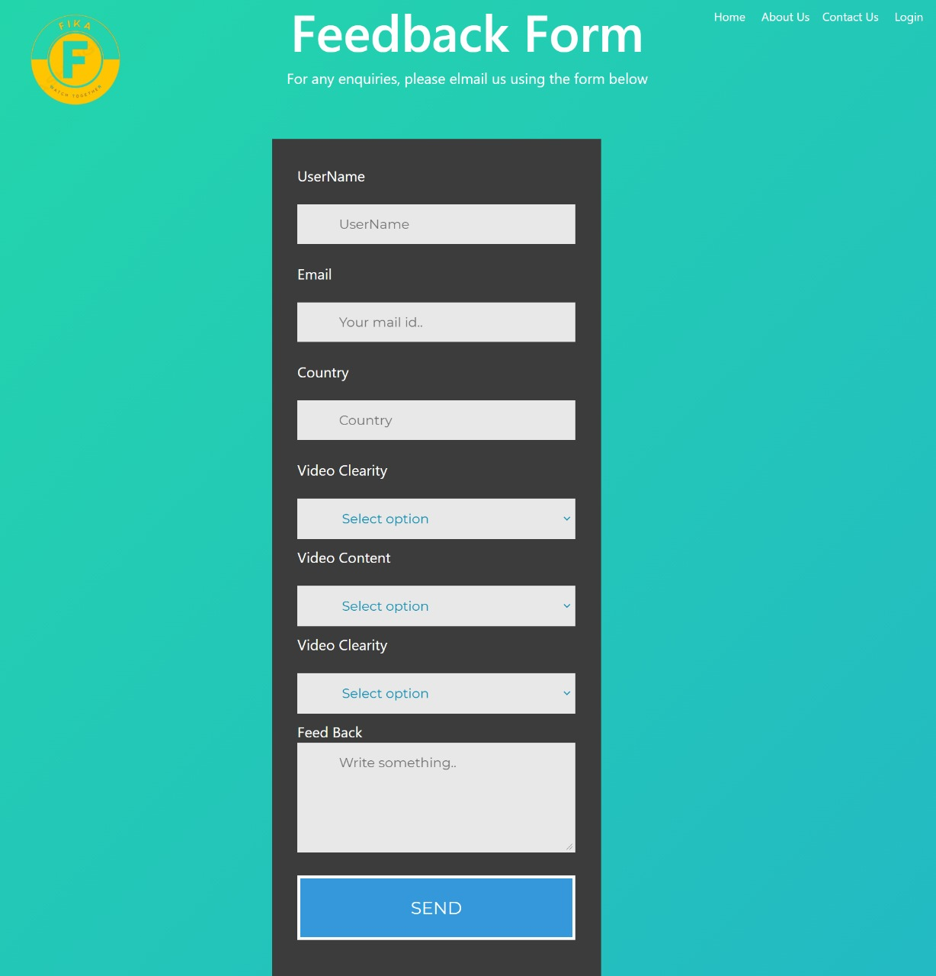

**8.ADMIN PAGE:**

This page is for the admin users of the website, it gives them an idea and the data and information of how many users are using their website, it also provides them with the ratings of the movie given by the users and the feedbacks given.

It displays the total number of users, feedbacks, ratings and reviews on the top. It also displays the top items, that is movies or shows based on the ratings received.

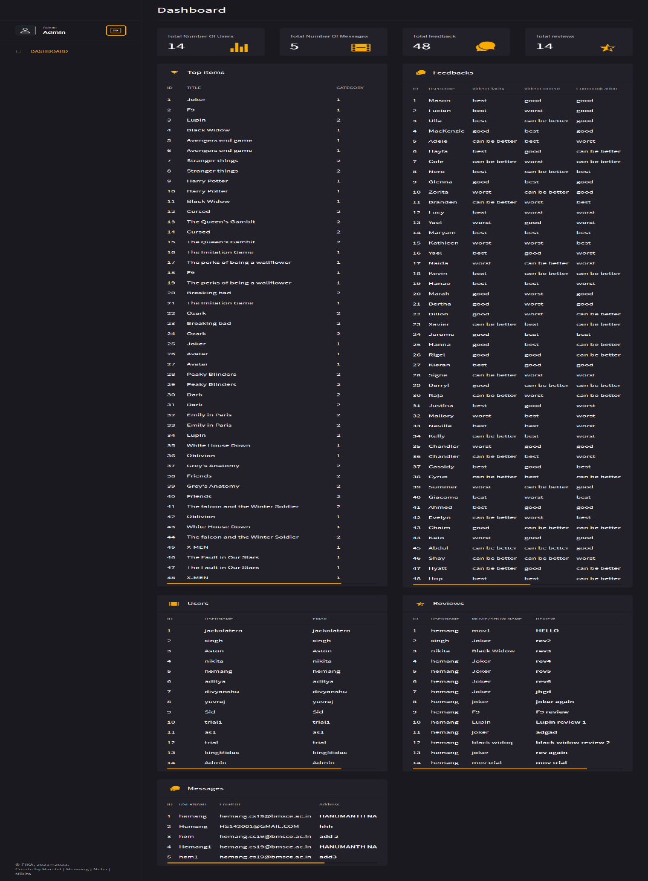

REFERENCES:

1. <https://codepen.io/stackoverflow>
2. <https://stackoverflow.com/>
3. <https://www.imdb.com/>